Week 2 – SPL 1
- Why is density an important material property in the context of sustainable manufacturing, particularly in transportation?
Density is important in sustainable manufacturing because reducing the weight of materials (i.e., using materials with lower density) helps lower CO₂ emissions, especially in transportation where fuel efficiency is directly affected by the vehicle’s mass.
- What does it mean when a material exhibits linear elastic behaviour, and what law does it follow at low strains?
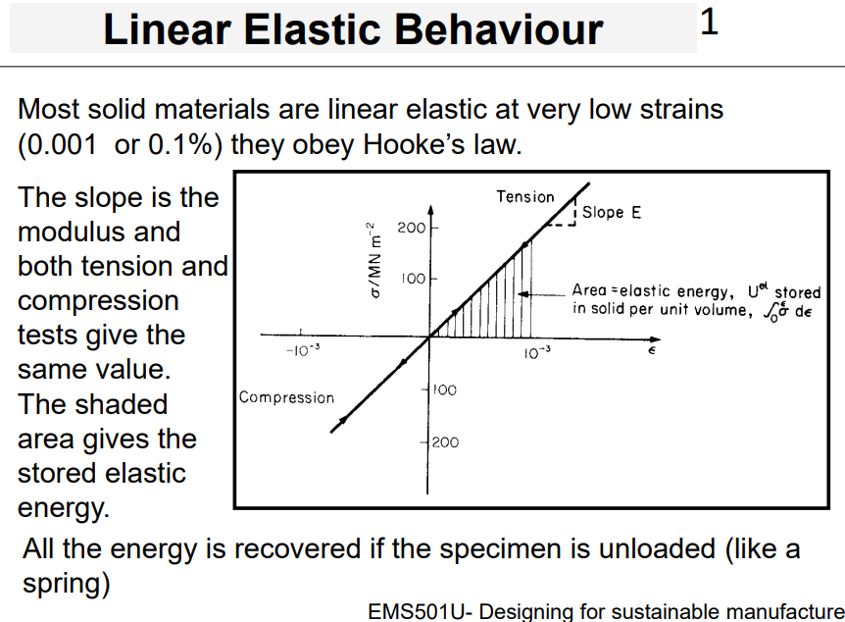
A material shows linear elastic behaviour when it deforms proportionally to the applied stress and returns to its original shape upon unloading — meaning all the energy is recovered. This behaviour is described by Hooke’s Law, and it typically occurs at very low strains (around 0.001 or 0.1%).

- Name and briefly describe the four types of moduli used to describe a material's elastic behaviour.
- Young’s Modulus (E): Describes a material’s response to tension or compression.
- Shear Modulus (G): Describes the material’s response to shear loading.
- Bulk Modulus (K): Describes how a material responds to uniform hydrostatic pressure.
- Poisson’s Ratio (ν): The negative ratio of lateral strain (ε₂) to axial strain (ε₁) in axial loading; dimensionless. 2/1.
- It is the negative of the ratio of lateral strain to axial strain.
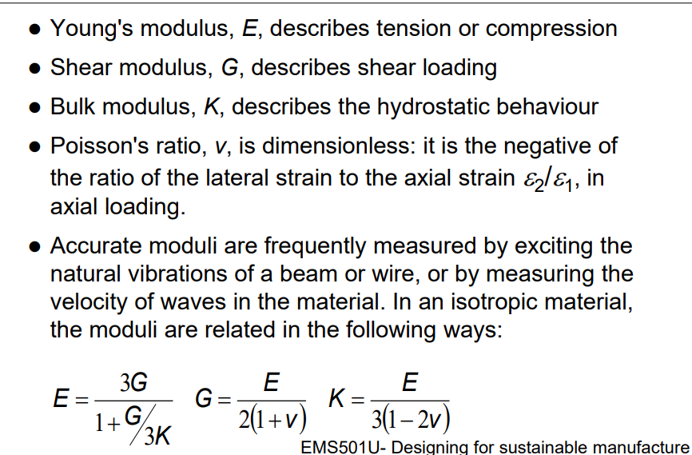

- In the context of linear elastic materials, what does the shaded area under the stress-strain curve represent? SLIDE 5
Represents the stored elastic energy or strain energy. This is the potential energy stored in the material, which can be fully recovered upon unloading.
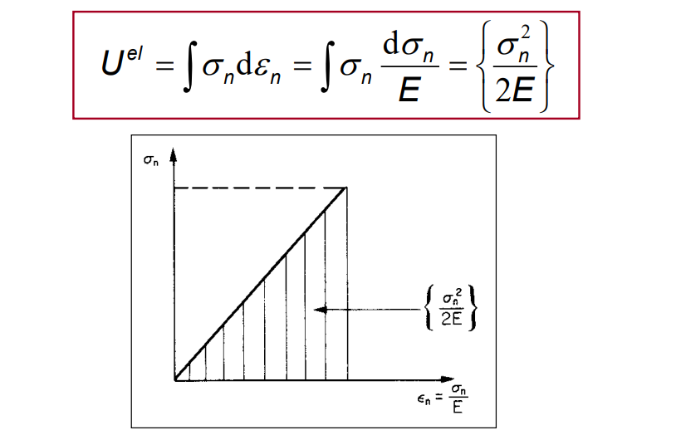
- What characterizes non-linear elastic behaviour, and which type of material typically shows this over large strains?
The material is still elastic but the relationship between stress and strain is not linear over the entire range. Rubbers (returns to its original shape, showing non-linear elastic behaviour.) can exhibit this type of behaviour over very large extensions -strains of up to 5 (or 500%) are possible. Most of the energy is recovered on unloading.
- What is anelastic behaviour, and why might it be desirable or undesirable in certain applications?
Anelastic behaviour means the material is still elastic (no permanent deformation), but the loading and unloading curves are not identical — some energy is dissipated in the cycle. This results in hysteresis.
- It’s desirable in applications like rubber where damping (e.g., reducing vibrations or noise) is needed.
- It’s undesirable in applications like bells, where you want minimal energy loss (use materials like spring steel, bronze, or glass).
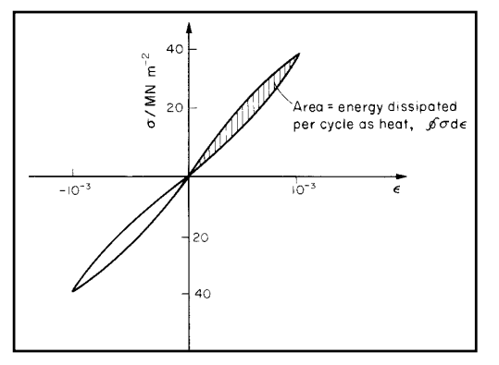
- What happens to a ductile metal like copper when it is loaded in tension beyond the initial linear region?
When a ductile metal (like copper) is loaded in tension beyond the initial linear region, the stress-strain curve becomes non-linear and the material begins to plastically deform. This means that any deformation beyond this point is permanent, even after the load is removed.

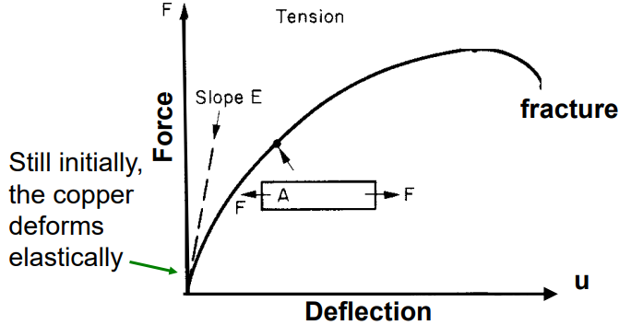
- What is a permanent set, and when does it occur during material deformation?
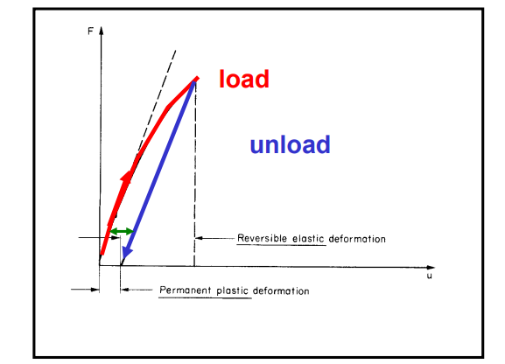
A permanent set refers to the permanent deflection that remains in a material after it has been loaded beyond its yield point and then unloaded. It indicates that the material has undergone plastic deformation and will not return to its original shape.

- What causes permanent extension in a material after fracture, and what visible phenomenon typically occurs before breaking?
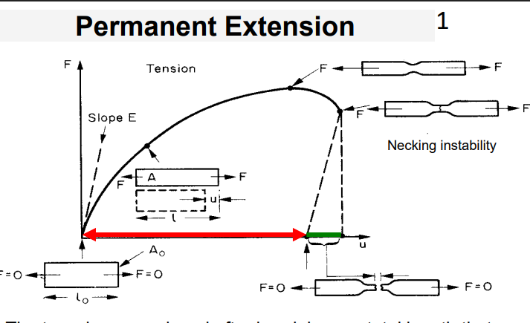
Permanent extension refers to the fact that, after fracture, the combined length of the broken pieces is slightly less than the length of the material just before breaking. This is because the material undergoes elastic recovery after the maximum force is removed.
Before fracture, necking usually occurs this is a visible instability where the material thins locally, concentrating stress and leading to failure.
Basically, new length is less than new length

- Define yield strength and explain what it indicates about a material’s behaviour.
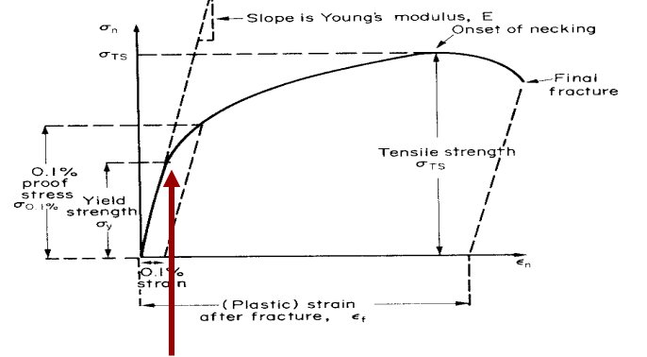
Yield strength is the stress at which a material begins to deform plastically. It is calculated as the force (F) divided by the original cross-sectional area (A₀): F/A
It marks the onset of permanent deformation — beyond this point, the material will not return to its original shape when unloaded.
also shows 0.1% proof stress

- What is proof stress, and why is it used instead of yield strength for some materials?
Proof Stress is used when a material does not exhibit a clear yield point (common in materials like aluminium alloys). It is the stress required to produce a small, defined permanent strain — typically 0.1% or 0.2%.
Difference between them:
Yield Strength is the stress at which a material begins to deform plastically. Up to this point, the material behaves elastically (i.e., returns to its original shape when the load is removed). It is typically seen as the point where the stress-strain curve first deviates from a straight line.
Proof Stress (often the 0.1% or 0.2% proof stress) is used for materials that do not have a well-defined yield point (e.g., some aluminium alloys). It is defined as the stress required to produce a small, specified amount of permanent strain (like 0.1%).
- What is tensile strength, and how does it differ from yield strength? BASICALLY UTS
Maximum stress a material can withstand before necking begins. It occurs after yielding but before fracture. After this point, the material becomes unstable and starts to neck — thinning locally until it eventually breaks.
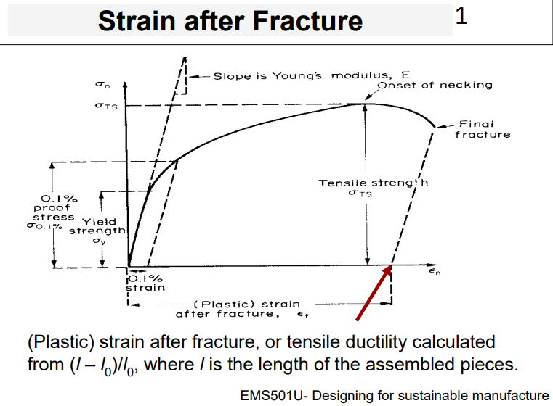
- What is meant by strain after fracture, and how is it calculated?
Strain after fracture, also known as tensile ductility, measures how much a material stretches before it breaks. It’s a way to quantify ductility.
A higher strain after fracture means the material is more ductile.

- How is the hardness of a material tested, and what does the result tell us about the material? HARDNESS TEST
In a hardness test, a pointed diamond or hardened steel ball (called an indenter) is pressed into the surface of the material.
- The deeper the indenter sinks, the softer the material.
- A softer material typically has a lower yield strength.
- What is the modulus of rupture, and how does it compare to tensile strength, especially in ceramics?
The modulus of rupture is the surface stress in a bent beam at the point of failure. Commonly used when it's difficult to grip samples for a standard tensile test for example, in brittle materials.
- In ceramics, the modulus of rupture is often about 1.3 times higher than the tensile strength.
- This is because in bending, only a small volume is subjected to the maximum stress, reducing the chance of encountering a large flaw.
- In simple tension, all flaws experience the maximum stress, which lowers the measured strength.
- What is the difference between toughness and fracture toughness, and how are they measured?
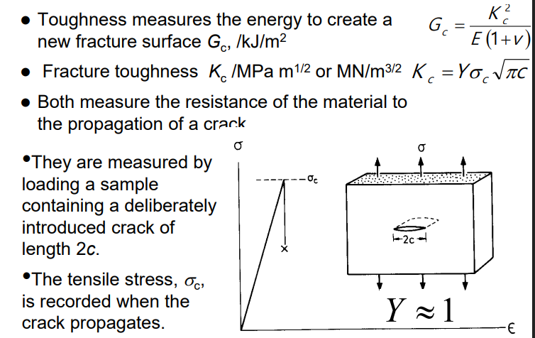
Toughness measures the energy required to create a new fracture surface — it reflects a material's ability to absorb energy before breaking. It’s denoted as Gc​ and measured in kJ/m².
Fracture Toughness (Kc) measures a material's resistance to crack propagation BASICALLY how well it can withstand the growth of an existing crack. It’s measured in MPa√m OR MN/m^3/2.
Measurement method:
A sample with a pre-made crack of length 2c is loaded in tension. The critical stress at which the crack propagates is recorded. These values help assess a material’s crack resistance, which is crucial in design.
- What is thermal conductivity, and how can it be affected by the material's composition?
Thermal conductivity λ (W/m·K) measure of how well a material conducts heat under steady-state conditions.
- Higher thermal conductivity means heat flows more easily through the material.
- It can be affected by composition like adding zinc to copper decreases its thermal conductivity.
This is because impurities and alloying elements scatter heat-carrying electrons or phonons, reducing heat flow.
Thermal conductivity - measure of the rate at which heat is conducted through a solid at steady state. It is measured by recording the heat flux q (W/m^2) flowing from a surface at temperature T1 to one at T2 in the material, separated by a distance X.
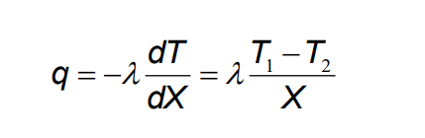
- What does the thermal expansion coefficient represent, and how is it related to volume expansion in isotropic materials?
α / K-1 is the thermal strain per degree.
For thermally isotropic materials (those that expand equally in all directions), the volume expansion per degree is approximately: ΔV≈3α
This property is important in applications where temperature changes can cause mechanical stress due to expansion or contraction.
- What factors increase the electrical resistivity of copper, and how does temperature affect it? I chatgpt this
The electrical resistivity of copper increases due to:
- Adding impurity atoms: this disrupts the regular atomic structure and scatters electrons, making it harder for current to flow.
- Mechanical deformation: plastically deformed copper has more defects, which also increase resistivity.
- Temperature: as temperature increases, so does resistivity due to increased atomic vibrations (phonon scattering).
- How can the magnetic properties of iron (Fe) be improved for applications like data storage?
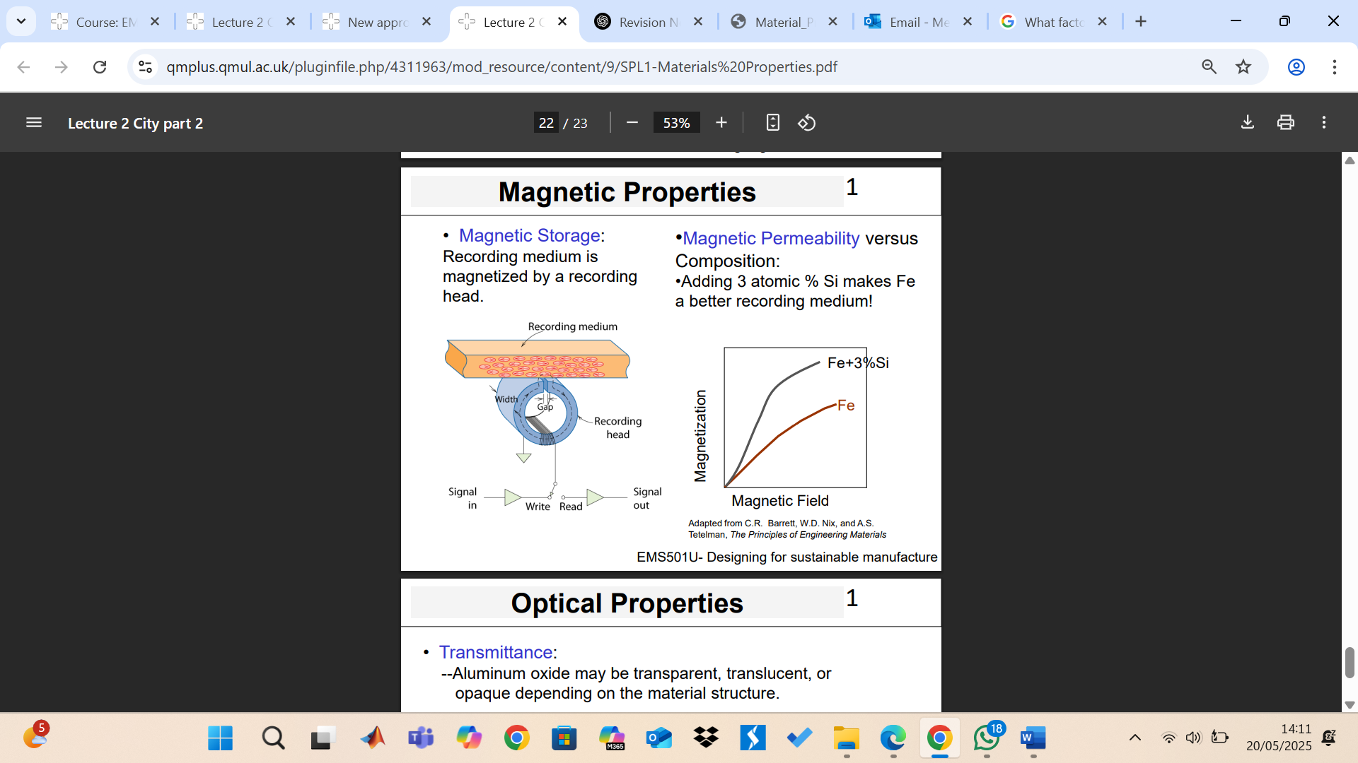
The magnetic properties of iron (Fe) can be improved by adding a small amount of silicon (Si).
- For example, adding 3 atomic % Si to Fe increases its magnetic permeability, making it better suited for magnetic recording and data storage.
- This modification reduces energy loss during magnetisation and improves magnetic response.
These enhancements make Fe+Si alloys ideal for applications like transformers, motors, and recording media.

OPTICAL PROPERTIES:
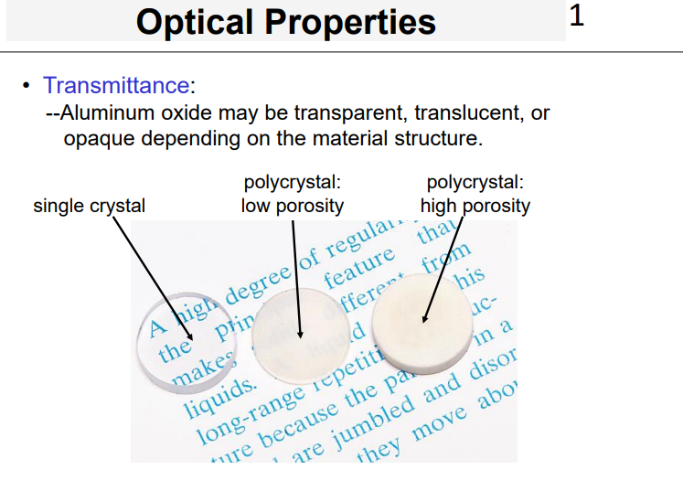
- A single crystal is typically transparent.
- A polycrystal with low porosity is translucent.
- A polycrystal with high porosity appears opaque.
Quiz:
Which of the following statements about non-linear elastic materials is TRUE?
A) They exhibit permanent deformation after unloading.
B) The stress-strain curve is linear at all strain levels.
C) The material fully recovers its original shape after unloading. Rubber- return to their original shape after unloading meaning they are elastic, not plastic.
D) The elastic modulus is constant throughout deformation.
Which condition would most likely increase the electrical resistivity of pure copper?
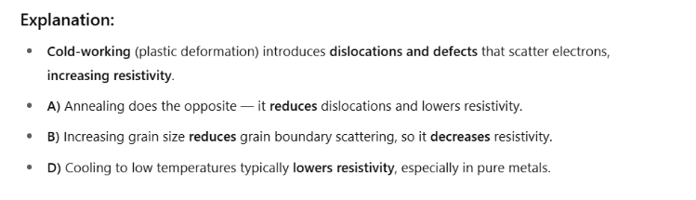
A) Annealing the copper to reduce dislocations
B) Increasing the copper's grain size
C) Cold-working the copper to introduce more defects
D) Cooling the copper to cryogenic temperatures

Which of the following is the most appropriate method for accurately determining the Young’s modulus of a material?
A) Measuring permanent elongation under tensile loading
B) Calculating surface hardness with a Brinell test
C) Measuring natural vibration frequency of a beam is mentioned in slide 4
D) Observing plastic deformation during compression
Explanation:
- The most accurate way to determine Young’s modulus is through dynamic methods, such as measuring the natural frequency of vibration or the speed of sound waves in the material.
- These techniques avoid the influence of plastic deformation or measurement error in strain gauges.
- Let’s break down the others:
  - Measures plastic behaviour, not elastic.
  - Brinell test is for hardness, not modulus.
  - Observes permanent deformation, which occurs after the elastic limit.

Which mechanical property is most relevant when selecting a material for a bell that must sustain vibration with minimal energy loss?
- A) Anelastic damping
B) High fracture toughness
C) Low Poisson’s ratio
D) High elastic modulus with low damping
Explanation:
- For applications like bells, energy loss is undesirable — you want the sound to resonate and sustain.
- So, the ideal material should have:
  - High stiffness (elastic modulus) for efficient vibration
  - Low damping to minimize energy dissipation

SPL 2
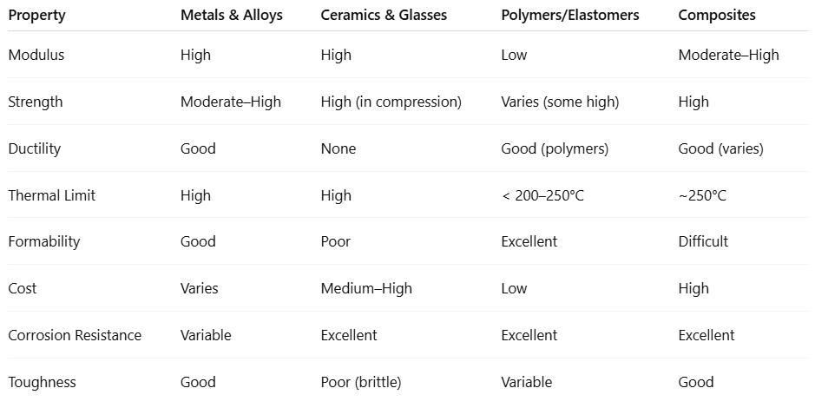

METALS AND ALLOYS
1. What are the main strengthening mechanisms used for metals and alloys, and how do they influence mechanical performance?
Metals and alloys are commonly strengthened by:
- Alloying – introducing different atoms into the metal matrix to hinder dislocation movement.
- Plastic deformation (e.g., cold working) – increases dislocation density, making further deformation harder.
- Heat treatment – used to modify the microstructure for increased hardness or strength.
These mechanisms improve strength but may affect ductility and fatigue resistance.
2. Why are metals considered ductile, and how does this ductility affect both their failure behaviour and their susceptibility to fatigue?
Metals are considered ductile, meaning they can undergo significant plastic deformation before fracture. This allows them to be easily formed and ensures that even high-strength alloys (e.g., spring steel with ~2% ductility) exhibit tough, ductile failure rather than brittle fracture.
However, this same ductility makes them more susceptible to fatigue, especially under cyclic loading. Additionally, some metals have poor corrosion resistance, requiring surface treatments or alloying for protection.

CERAMICS AND GLASSES
3. What are the key differences in tensile and compressive strength in ceramics and glasses, and how does this relate to their brittleness? - ceramics stronger in compression than tension
In ceramics and glasses, the tensile strength is governed by brittle fracture, while the compressive strength is typically 10 times higher and is governed by brittle crushing.
This large difference arises because ceramics are extremely sensitive to tensile flaws (like cracks), which propagate easily. In compression, these flaws are closed rather than opened, making the material much stronger. This behaviour is a core reason why ceramics are considered brittle.

TENSION BAD | COMPRESSION GOOD
- You're pulling it apart. | - You're squishing the cup.
- That crack opens up — and the material snaps easily. | - That same crack gets pushed closed, not opened.
- That's called brittle fracture. | - So it doesn’t cause failure as easily.
4. Why are ceramics and glasses considered difficult to design with, and what properties make them suitable for specific applications like cutting tools or bearings?
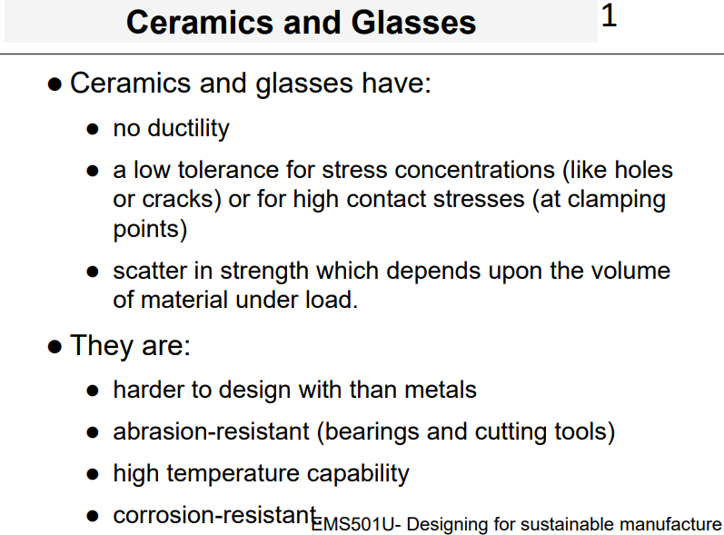
Ceramics and glasses are difficult to design with because:
- They have no ductility, so they fail suddenly without warning.
- They have a low tolerance for stress concentrations (like holes or cracks).
- Their strength is variable, depending on the volume under load therefore, larger components are more likely to contain a critical flaw.
However, they are useful in certain applications because they are:
- Abrasion-resistant → great for bearings and cutting tools.
- Have high-temperature capability → withstand extreme heat.
- Are corrosion-resistant → chemically stable in harsh environments.

POLYMERS
5. Polymers are much lighter and have much lower stiffness than metals, yet some are nearly as strong.
What does this imply about their modulus, density, and potential use in lightweight design?
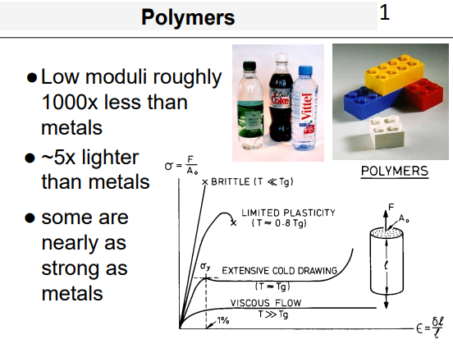
Polymers have a low modulus (they're flexible), but they are also very lightweight. This means that even though they aren’t stiff, some can still achieve comparable strength-to-weight ratios to metals.
So, in lightweight design, polymers are valuable because:
- Their low density reduces weight significantly.
- Certain formulations offer high strength, even with low stiffness.
- They’re useful where large elastic deformation is acceptable and weight saving is critical (e.g., packaging, consumer products, car interiors). IDK IF THIS IS CORRECT

6. What makes polymers temperature-sensitive, and how does this affect their mechanical performance across different conditions?
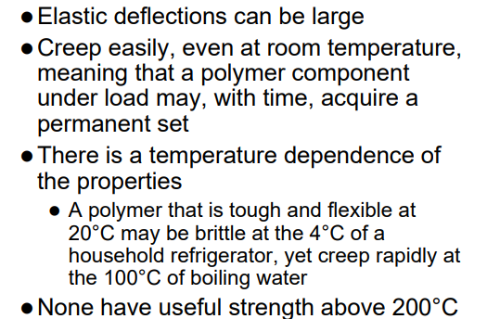
Polymers are highly temperature-sensitive, meaning their mechanical properties change significantly with temperature. For example:
- A polymer that is tough and flexible at 20°C may become brittle at 4°C (e.g., inside a refrigerator).
- At higher temperatures (e.g., 100°C), it may creep — slowly deform under load.
- No common polymers maintain useful mechanical strength above 200°C.
This temperature dependence must be carefully considered in design applications, especially where loads and thermal environments vary.
BASICALLY, match the right polymer to the right temperature range, or material e.g. snap when it’s too cold
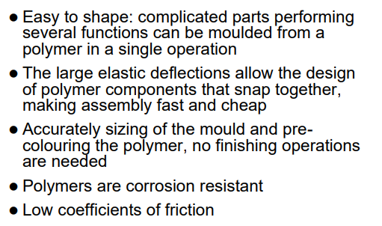
7. Why are polymers considered efficient for manufacturing, and what features make them particularly useful in product design and assembly?
Polymers are highly efficient for manufacturing because:
- They are easy to shape — complex parts can be moulded in one operation.
- Large elastic deflections allow components to be designed for snap-fit assembly, which is fast and cheap.
- No finishing required — parts can be accurately sized in the mould and pre-coloured during production.
- They are also corrosion-resistant and have low coefficients of friction, adding to their versatility in design.
These properties make polymers ideal for high-volume, low-cost manufacturing and consumer product design.

Elastomers
8. What makes elastomers different from other polymers, and how does their stress–strain behaviour reflect this?
Some polymers can be cross-linked to become elastomers.
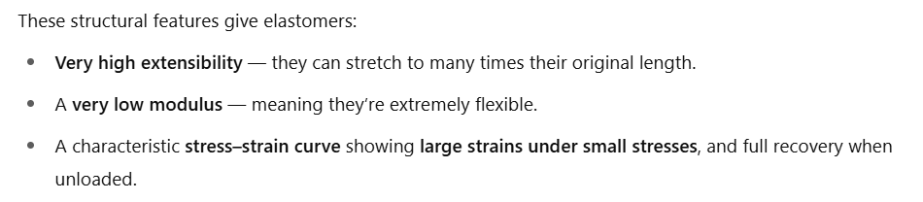
These have many of the properties of other polymers including:
- high extensibility
- low modulus
- ~1/100000th of a metal

9. List and explain the four requirements a polymer must meet to behave like an elastomer.
- The temperature is above the glass transition temperature, Tg.
- The forces between the molecules must be weak, like those in a liquid.
- The polymer must not be highly crystalline. Highly crystalline regions restrict movement. Elastomers need to be mostly amorphous to stretch freely.
- The polymer should be lightly cross-linked.

Composites
10. What are composites, and how do they combine material classes to enhance performance?
Composites are engineered materials made by combining two or more distinct material classes, usually a matrix (often a polymer like epoxy or polyester) and a reinforcement phase (such as glass fibre, carbon fibre, or Kevlar).
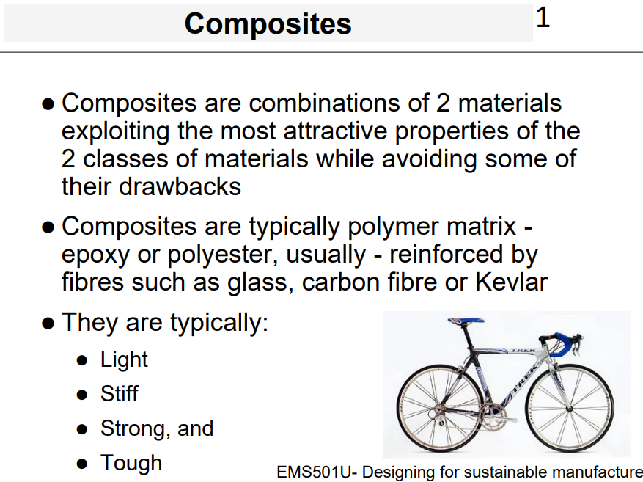

11. What are the main limitations of composites in engineering, and why are they still used despite these drawbacks
- Polymer composites cannot be used above 250°C
- Composite components are expensive
- Relatively difficult to form and join.
- The designer will use them if the added performance justifies the added cost.

